Reading Athletic Club Risk Assessment
Risk Assessment Name: Click or tap here to enter text.
Document & Version No: RA_Click or tap here to enter text..Click or tap here to enter text.
Initial Date: Click or tap to enter a date.
Initial Reviewer Click or tap here to enter text.
Review period (in years): Click or tap here to enter text.
Last Review Date: Click or tap to enter a date.
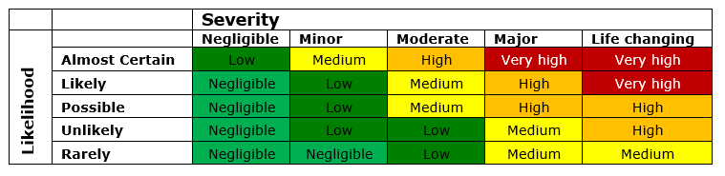
Last Reviewed by: Click or tap here to enter text.
Type of Risk Assessment Choose an item.
Are there fire hazards? Choose an item.
Are there electrical hazards? Choose an item.
Are there chemical hazards? Choose an item.
Should the stadium control some of the risk? Choose an item.
Hazards | Potential Harm | Inherent Risk Level | Existing Controls | Existing Risk Level | Additional Controls Advised | Target Risk Level
Click or tap here to enter text. | Click or tap here to enter text. | Choose an item. | Click or tap here to enter text. | Choose an item. | Click or tap here to enter text. | Choose an item.
Click or tap here to enter text. | Click or tap here to enter text. | Choose an item. | Click or tap here to enter text. | Choose an item. | Click or tap here to enter text. | Choose an item.
Click or tap here to enter text. | Click or tap here to enter text. | Choose an item. | Click or tap here to enter text. | Choose an item. | Click or tap here to enter text. | Choose an item.
Click or tap here to enter text. | Click or tap here to enter text. | Choose an item. | Click or tap here to enter text. | Choose an item. | Click or tap here to enter text. | Choose an item.
Click or tap here to enter text. | Click or tap here to enter text. | Choose an item. | Click or tap here to enter text. | Choose an item. | Click or tap here to enter text. | Choose an item.
Click or tap here to enter text. | Click or tap here to enter text. | Choose an item. | Click or tap here to enter text. | Choose an item. | Click or tap here to enter text. | Choose an item.
Click or tap here to enter text. | Click or tap here to enter text. | Choose an item. | Click or tap here to enter text. | Choose an item. | Click or tap here to enter text. | Choose an item.
Click or tap here to enter text. | Click or tap here to enter text. | Choose an item. | Click or tap here to enter text. | Choose an item. | Click or tap here to enter text. | Choose an item.
Click or tap here to enter text. | Click or tap here to enter text. | Choose an item. | Click or tap here to enter text. | Choose an item. | Click or tap here to enter text. | Choose an item.
Click or tap here to enter text. | Click or tap here to enter text. | Choose an item. | Click or tap here to enter text. | Choose an item. | Click or tap here to enter text. | Choose an item.
Click or tap here to enter text. | Click or tap here to enter text. | Choose an item. | Click or tap here to enter text. | Choose an item. | Click or tap here to enter text. | Choose an item.
Click or tap here to enter text. | Click or tap here to enter text. | Choose an item. | Click or tap here to enter text. | Choose an item. | Click or tap here to enter text. | Choose an item.
Click or tap here to enter text. | Click or tap here to enter text. | Choose an item. | Click or tap here to enter text. | Choose an item. | Click or tap here to enter text. | Choose an item.
Click or tap here to enter text. | Click or tap here to enter text. | Choose an item. | Click or tap here to enter text. | Choose an item. | Click or tap here to enter text. | Choose an item.
Click or tap here to enter text. | Click or tap here to enter text. | Choose an item. | Click or tap here to enter text. | Choose an item. | Click or tap here to enter text. | Choose an item.

Assumptions
Click here to use this space to record any assumptions made in this risk assessment

Rationale
Click here to use this space to record any rationale for the decisions or judgements made in this risk assessment

Action Plan
Click here to use this space to record the action plan for this risk assessment with sufficient details such as dates and responsibilities

Issues
Click here to use this space to record any ongoing issues that relate to this risk assessment

